**Bug report 1**

| **ID** | 1 |  |
| --- | --- | --- |
| **Severity** | Major |  |
| **Created at** | Dubchak L.P. |  |
| **Reporter** | Dubchak L.P. |  |
| **Environment (Dev/Stg/Prod)** | Prod |  |
| **Status** | New |  |
| **Summary** | Duplicate name is allowed when User creates new list with same name on Wishlist page |  |
| **Application type (Desktop or Mobile)** | Desktop |  |
| **Reproducibility** | always |  |
| **Preconditions** | 1. User is logged-in 2. The "Wishlist" with name “abcdefghk” created |  |
| **Steps to reproduce** | 1. Open the site <https://www.bookdepository.com/> 2. Click on "Wishlist" button 3. Click the “Create new Wishlist”button 4. In the “Create new Wishlist” pop up enter the label name “abcdefghk” 5. Click on "Create" button 6. Pay attention to the duplicate label name created |  |
| **Actual Result** | Duplicate name is allowed when User creates new list with same name on Wishlist page |  |
| **Expected Result** | A duplicate label name isn’t created and ““Label exists. You already have a “Wishlist” with that name” informational message is displayed |  |
| **Attachments** |  |  |

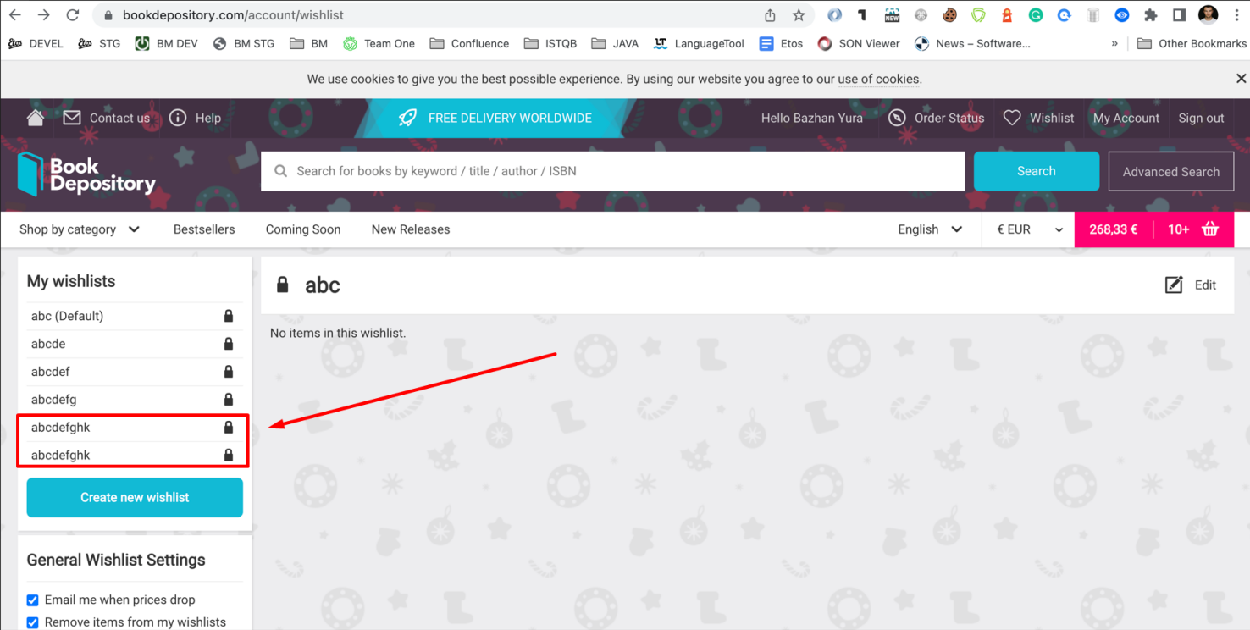

**Bug report 2**

| **ID** | 2 |  |
| --- | --- | --- |
| **Severity** | Minor |  |
| **Created at** | Dubchak L.P. |  |
| **Reporter** | Dubchak L.P. |  |
| **Environment (Dev/Stg/Prod)** | Dev |  |
| **Status** | New |  |
| **Summary** | The "Add to Basket" button is displayed instead of "Pre-Order" on the "Wishlist" page |  |
| **Application type (Desktop or Mobile)** | Desktop |  |
| **Reproducibility** | always |  |
| **Preconditions** | 1. User is logged-in 2. The book "Display: Appearance, posture and behavior in the animal kingdom” is added in Wishlist |  |
| **Steps to reproduce** | 1. Open the site <https://www.bookdepository.com/> 2. Click the “Wish list” button 3. Pay attention to the “Add to basket” button |  |
| **Actual Result** | The "Add to Basket" button is displayed instead of "Pre-Order" on the "Wishlist" page |  |
| **Expected Result** | "Pre-Order" button should be displayed on the "Wishlist" page |  |
| **Attachments** |  |  |

